1.   
   Apache kafka helps in building Event-Driven Applications.

What is an Event?

1.  **For example**:   
   When a user login a system, an event is generated to indicate that a login took place.  
   When a new Product is created, the MS can publish “ProductCreateEvent”.  
   When a new order is placed, an event is generated to indicate that some order has been placed.  
   So events are used to represent the changes in the state of our applications.
2. **Topic Name Convention with Example**:  
   

Message Vs. Event.

1. In online tutorial, Books, you will see these two terms are used interchangeably.
2. You can think of Kafka Message as a message envelop that carries something inside it and the event data is the content of this message envelop.
3. The event data can be of different formats.  
   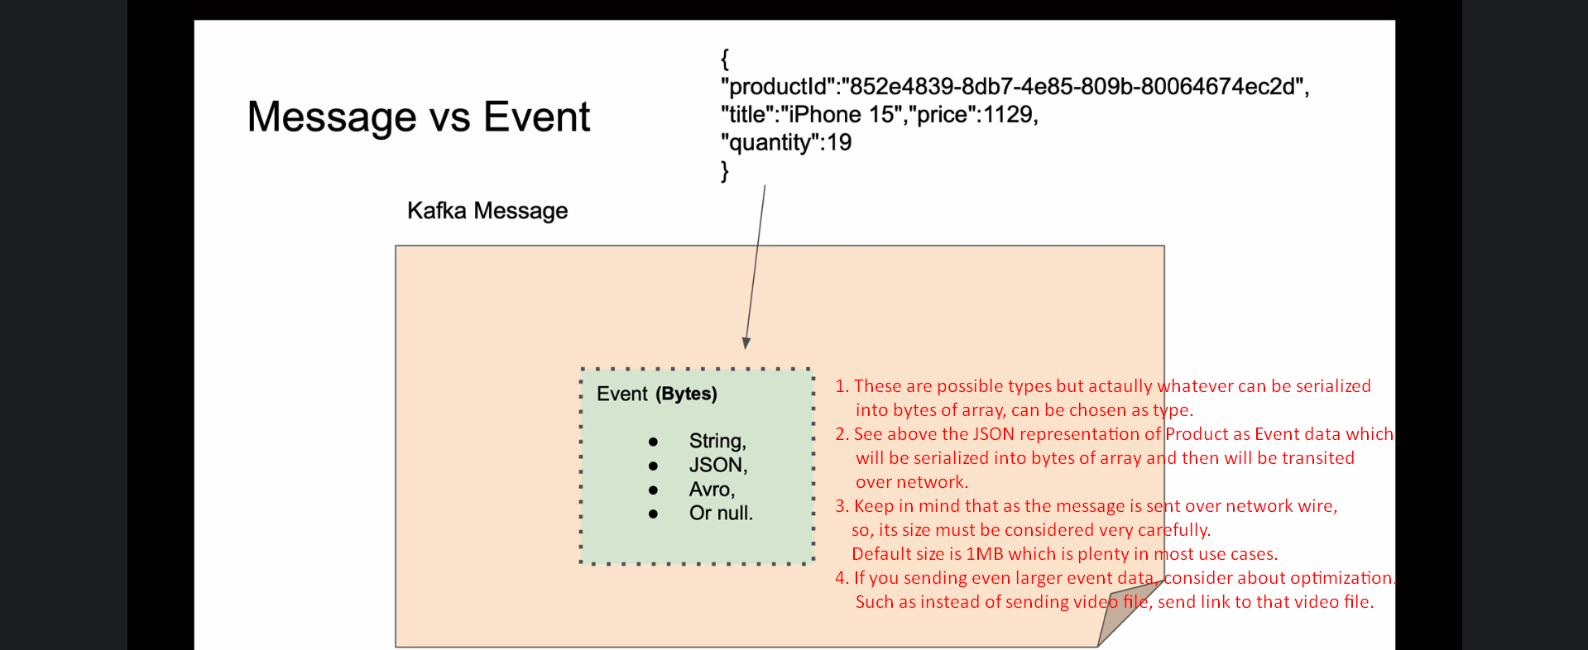
4. 